GOOD GOVERNANCE MODEL

https://www.groundwatergovernance.org/what-is-effectiveness-and-efficiency-in-good-governance/

Governance is the process of decision-making and the process by which decisions are implemented (or not implemented) within organizations, businesses, and institutions. It includes the mechanisms through which decisions are made and how they are executed. Good governance is a process that enables stakeholders to make decisions that are in the best interest of the organization, business, or institution.
There are two key concepts in good governance: effectiveness and efficiency. Effectiveness is the ability to produce the desired results. Efficiency is the use of resources in the most efficient manner possible to achieve the desired results.
The concept of good governance is not new. It has been around for centuries and has been practiced in various forms by different cultures. The modern concept of good governance has its roots in the late 18th century and the Age of Enlightenment. At that time, there was a growing belief that reason, logic, and scientific method could be applied to all aspects of life, including government. This belief led to a series of political and social reforms that sought to improve the effectiveness and efficiency of government.
The concept of good governance has since been adopted by organizations, businesses, and institutions around the world. It is now widely recognized as a key element of successful organizations, businesses, and institutions.

A good government function entails balancing budgets, eliminating waste, and eliminating duplication in its operations. Governors can improve governance by developing strategies based on the most recent research and information. Governance is an important component of any organization’s ability to take care of its business. Accountability and oversight are critical elements of governance, which is essential to a well-run and efficient state. To achieve good governance, according to the United Nations, it is necessary to participate, uphold the rule of law, be transparent, responsive, and open-minded, inclusive, efficient, effective, and accountable.

The direction, effectiveness, supervision, and accountability of an organization are all ensured by good governance. A person demonstrating this type of willingness and ability to act in the best interests of the organization ensures that effective, open, and ethical processes are carried out, that they are following the law, and that they are subjected to scrutiny.

When efficiency and effectiveness are present, the maximum amount of product is possible. It is necessary to be efficient and effective to reduce the risk of performing a task. Efficiency and effectiveness are required for achieving the outcomes that an organization or stakeholders require.

What Is Efficiency and Effectiveness?
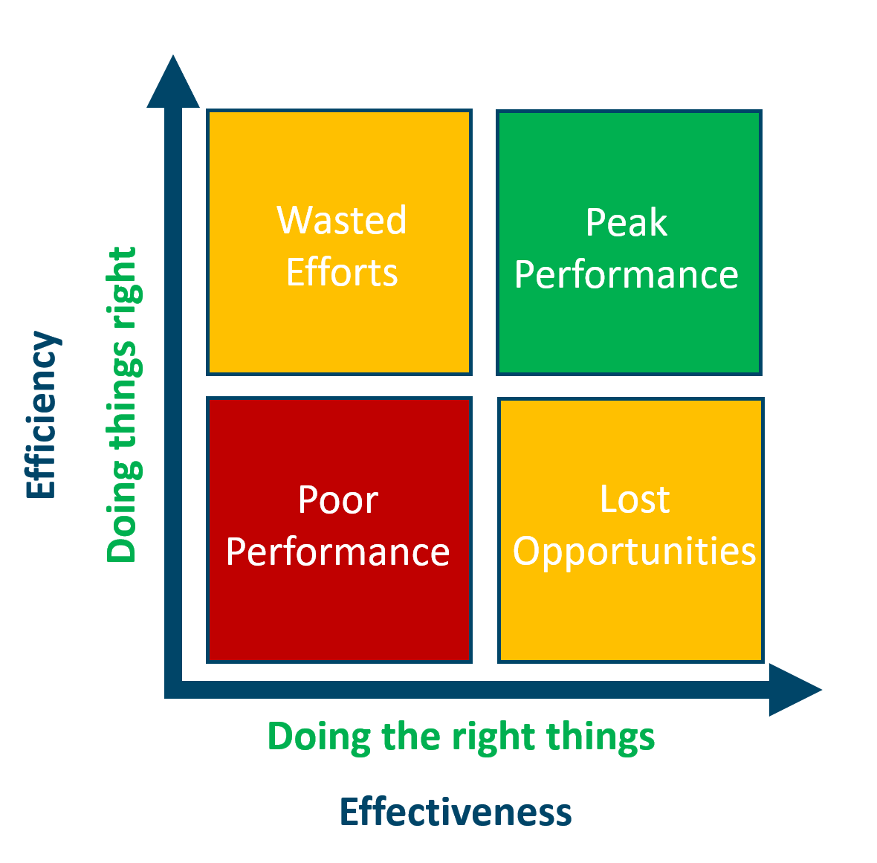

When efficiency is achieved, the least amount of waste, effort, and time is incurred because of producing an intended result. An effectiveness measure is a measure of how well an organization produces a better result, one that delivers more value or results in a better way.

Profit maximization is critical for efficient businesses. In most cases, efficiency is used over effectiveness. A section of Agile programmers is responsible for the efficiency of an Agile program. If you want to get started, do something that is less rushed and more effective rather than trying to make it more effective at first. There is a significant distinction between being busy and being productive. The goal of efficiency is to be able to perform the right things. In contrast to learning while doing, iterate is a better approach.
You cannot understand everything about a task or process until you try it for yourself. The key to balancing effectiveness and efficiency is to go about things in the same manner experts advise when doing something for the first time. This is the best way to handle anything in life. When I first learned rowing, I did not care what efficiency I achieved; rather, I just wanted to row well and get better.
In today’s world, both efficiency and effectiveness are important. It is estimated that inefficient practices can lead to waste and that ineffective practices can be ineffective and even harmful. Using a lot of energy to produce a less effective product can be counterproductive, for example.
It is not always easy to measure the efficiency and effectiveness of a project. Nonetheless, there are ways to assess efficiency and effectiveness, as well as ways to improve them. One way to measure efficiency is to look at how long it takes to create a good or service. It is possible to measure effectiveness by counting the amount of money saved.

The Importance of Effectiveness Over Efficiency
In the end, efficiency is the most important factor, but effectiveness is equally as important. The efficiency of an act is measured by how well it is completed, whereas the effectiveness of something is measured by its usefulness. A car, for example, is a powerful form of transportation that can move people across long distances, to specific destinations, but it may not be as efficient as a bike due to its fuel consumption. In contrast to productivity, which is defined as the act of connecting input and output, input and output are meaningless. You should do something well enough to be efficient. An effectiveness, on the other hand, is something that is done correctly. The fuel efficiency of a car, for example, may be impressive, but its effectiveness in moving people from one location to another is not.

What Is Meant By Effective Governance?

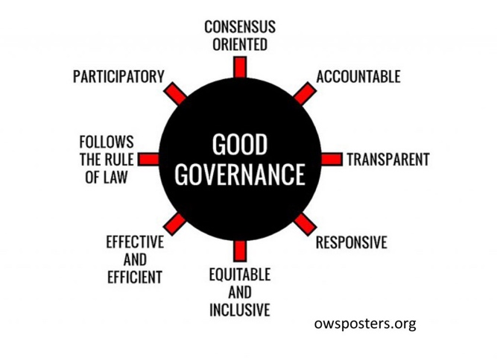
Evaluating the process of governing is based on good governance as a normative or evaluative attribute. In terms of human rights, it refers primarily to the process of carrying out public affairs, managing public resources, and ensuring the realization of human rights for the benefit of the people.
The best governors can plan and think strategically about their strategy as they lead the state. Governance entails authority, accountability, leadership, guidance, and control. Democracy will remain stable and successful in the future if we exercise it and conduct it correctly in our organizations and communities. The United Nations Framework for Good Governance is divided into eight categories: participation, rule of law, coordination, consistency oriented, equitable and inclusiveness, effectiveness, and efficiency, and accountability. Good governance necessitates the implementation of eight major principles. Good governance is based on eight fundamental principles: ethics, risk management, compliance, and administrative action.

Why Good Governance Matters
Governance also has a moral aspect to it. This entails obeying the rule of law, protecting human rights, and avoiding abuse and corruption. It is critical to implement effective governance to foster trust and confidence in society, as well as to foster social cohesion.
Economic growth can also be accomplished through proper governance. The ideal governance practices are those that reduce risks and create a stable environment for businesses to thrive. It can be advantageous for businesses to have access to new markets and to work more efficiently with other businesses. Good governance is required for the success of any business.

Effectiveness And Efficiency in Good Governance Tagalog
For good governance to be effective and efficient, it is important that decision-makers have a clear understanding of the issues at hand and can make informed decisions. Furthermore, good governance requires transparency and accountability to ensure that those in power are held accountable for their actions. Lastly, good governance also necessitates the participation of all stakeholders in the decision-making process to ensure that everyone has a say in how the country is run.
The combination of processes and institutions that produce good results while utilizing resources wisely is what makes governance great. Good governance entails managing public affairs in such a way that its human rights are respected while ensuring due regard for its law and practice. Governance is distinguished by six pillars: integrity, risk management, compliance, governance by review and management, and so on. The rule of law is essential for good governance; it is based on participatory, consensus, accountability, transparency, responsive, effective, and efficient, equitable, and inclusive practices. You may be able to improve the performance of your company, expand it in ways that increase productivity and stability, and open it up to a whole new world of possibilities.

What Is Good Governance in Your Own Words?
This is the conclusion. Finally, good governance entails the proper management of the state, society, and resources. It is designed to protect the interests of all people, regardless of their position on a specific issue. focuses on issues such as public sector management, the legal framework for development, accountability, transparency, and open data sharing.

Accountability In Good Governance
Accountability is a key component of good governance. It is essential for public officials to be accountable to the people they serve. Accountability promotes transparency and encourages public participation in decision-making. It also helps to prevent corruption and ensure that public resources are used efficiently and effectively.
When it comes to governance, good governance is defined as an act that is normative or evaluative. The only true test of good governance is the extent to which it upholds human rights. A healthy governance system is a mutually reinforcing factor. Human rights cannot be respected and protected in a sustainable manner without good governance. Democracy can benefit from good governance reforms if the public has a greater say in how they are carried out. Furthermore, they build mechanisms for including multiple social groups in decision-making processes. Principles such as accountability, transparency, and participation are critical for good governance efforts in the fight against corruption.

Participation In Good Governance
Governance is the process of decision-making and the process by which decisions are implemented (or not implemented) within an organization or group. Good governance is about making decisions that are in the best interests of the organization or group, and about ensuring that those decisions are implemented effectively and efficiently. Participation in governance is about having a say in the decision-making process, and about being able to hold decision-makers accountable for the decisions that are made. It is about ensuring that the voices of all stakeholders are heard, and that the interests of all stakeholders are considered. Participation in good governance is essential to the success of any organization or group. It helps to ensure that decisions are made in the best interests of the organization or group, and that those decisions are implemented effectively and efficiently.
A good governance principle states that everyone has a right to be treated equally and that all should be treated with respect. It entails ensuring that decision making, and enforcement are carried out in accordance with rules and regulations. All members of society must have access to the resources and opportunities that allow them to thrive. A positive relationship is formed between good governance and social security by looking at rural areas’ inevitability of good governance. The study examines the role of social security in the preservation of culture. By bringing all structures into the instrumentation, good governance seeks to promote peace, security, and stability. Because of their resistance to accountability, African governing elites are labeled as corrupt and have a double-barrel interpretation of good governance.
However, it is a component of the conflict prevention system. Good governance balances the separation of power within institutions while ensuring that their performance does not clash. A rural development program is a set of policies and projects that are intended to raise and sustain the standard of living in rural areas. To achieve its goal, the society seeks to establish an economic base that will produce progressively higher levels of output and develop a knowledge and attitude base. Governance has increasingly been linked to all forms of evils within societies, and poor governance is now regarded as the root cause. The goal of social security is to provide a safe and secure financial future for members of the poor. Social Security is becoming increasingly difficult to maintain because of the confluence of challenges that we all face.
To ensure that all members of society have access to and can participate in social life, we must increase the number of aspects of social life. To preserve their culture and traditions, the rural people must be encouraged to boost the economy, which is necessary for the people in the rural areas to be able to pass on their culture and traditions. When there is conflict, mistrust, or fear, knowledge transfer becomes a major issue. It is common for local knowledge to be depleted because of this. As one example of good governance, consider the continuous enthronement of good governance that has resulted in the rise of some emerging world powers such as the United States. Poorer countries, including those that are impoverished, lack social security, crime, and hunger, are the most important factors to consider when assessing good governance at the national level. Our culture and traditions must be passed down from generation to generation if we are to have a stable social system.
Despite the presence of academic forums in Sri Lanka, there is still a significant divide between the discourse on governance, human rights, and social progress. A research tool with content validity and reliability of 0.986 was obtained from 353 government sectors. The goal of the study was to develop competency factors for Good Governance in government procurement.

The Importance of Public Participation In Governance
By increasing public participation in governance, we can ensure that government decisions are based on what the public needs and that the public has a voice in how their government spends their money. It is critical to involve the public in the decision-making process to ensure that government policies are tailored to meet community needs. Public involvement also helps to ensure that government services are effective and relevant to the community.

Institutional Access Access
In the United States, “institutional access” generally refers to the legal right of government officials and employees to access and use government facilities, services, and information. This right is typically granted through legislation or executive orders. In some cases, institutional access may also be granted to private individuals or organizations, such as when they are contracted by the government to provide services or when they are working on behalf of the government.

What Is Institutional Access and How Can I Get It?
What is institutional access and how do you find it?
A journal’s institutional access is defined as access to an online Journal for a single institution or a group of individuals who are authorized to do so. There are no exceptions to the rule for multiple campuses.
How do I obtain a copy of an APA paper?
There are websites where you can download full-text content for free. If you are not connected to your institutional affiliation, please visit our APA Members and Individuals page to see if you can access APA resources through a subscription or on-demand basis. Using the website, you can compare subscription plans online.

